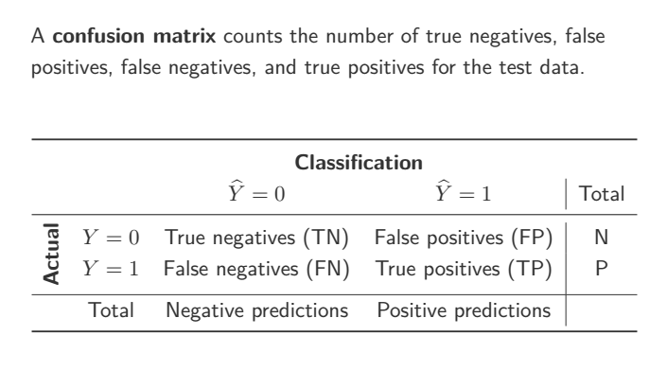

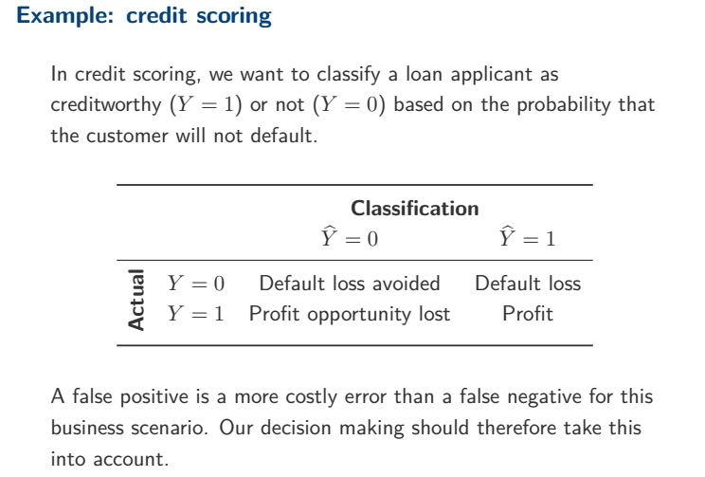

|  |  |  |  |  |
| --- | --- | --- | --- | --- |
| Classification | | | | |
|  |  | $$\hat{Y}=0$$ (Nonresponse) | $$\hat{Y}=1$$ (Response) | Total |
| Actual | Y=0  (Nonresponse) | Advertisement cost saved(TN) | Useless advertisement cost(FP) | N |
| Y=1  (Response) | Profit opportunity lost(FN) | Profit(TP) | P |
| Total |  | Negative predictions | Positive predictions |  |